Module 3 - PL/SQL Programming
Exercise 1: Control Structures

Creating customer table:
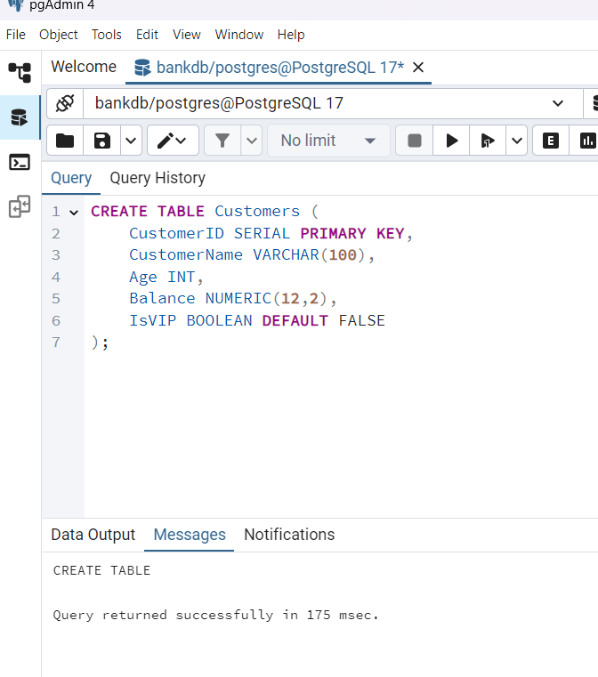
Creating loan table:
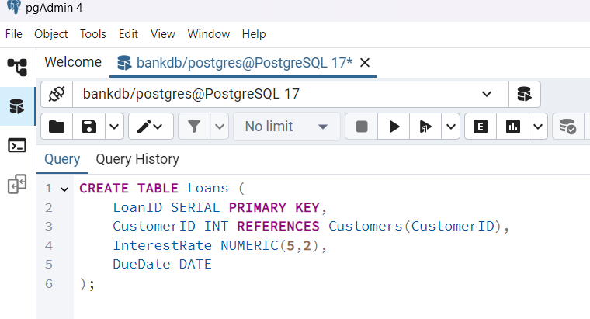

Insert sample customer data:
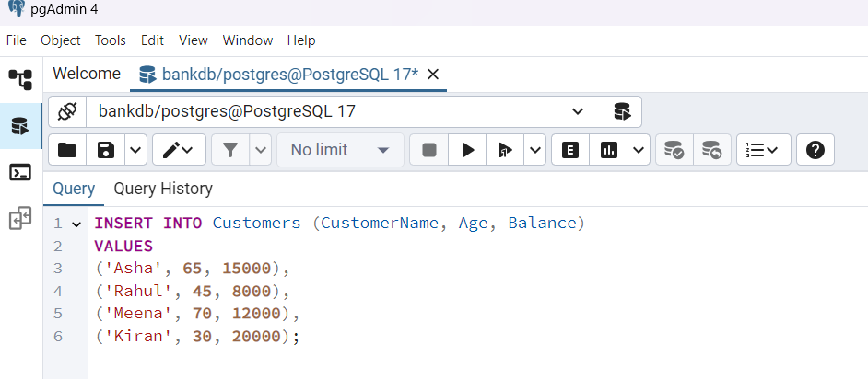
Insert sample loan data:
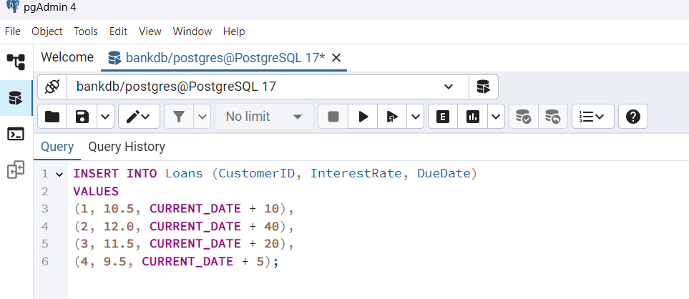

Scenario 1: Apply 1% discount for customers above 60:
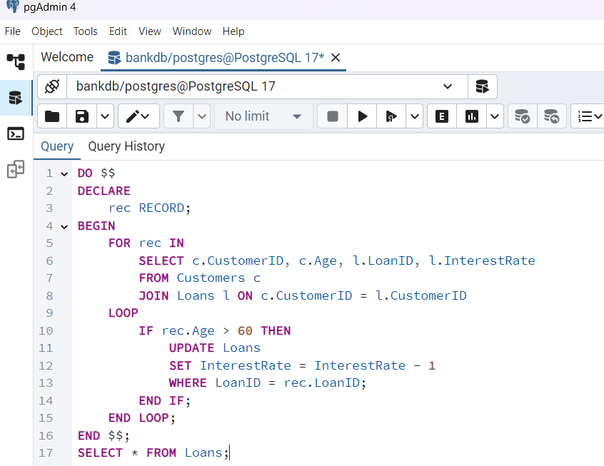
Output of scenario 1:
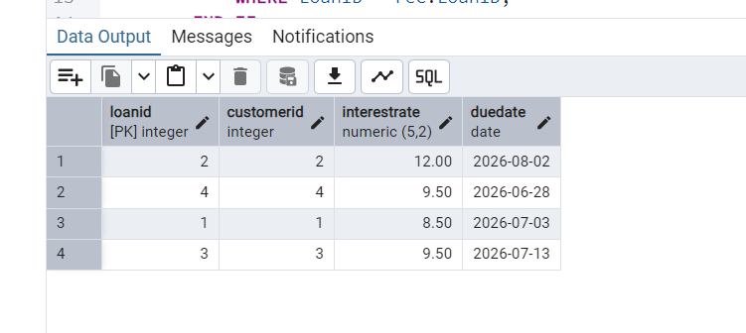
Scenario 2: Set VIP for customers with balance above 10000:
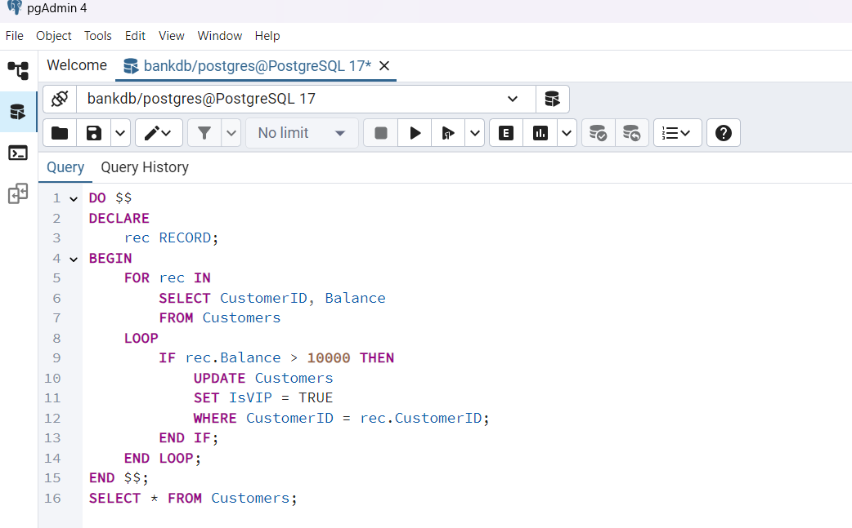
Output of scenario 2:
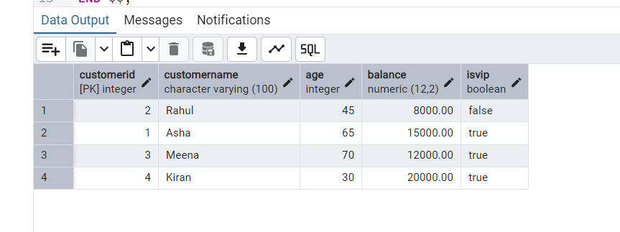
Scenario 3: Print reminders for loans due in next 30 days:
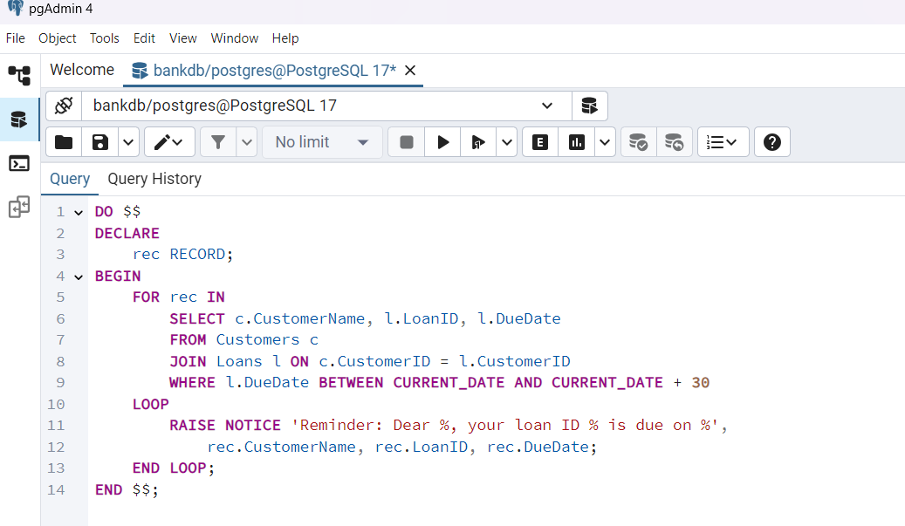
Output of scenario 3 :
